ADVENTURE WORKS · TECHNICAL SUPPORT

Tire Won't Hold Air or Leaks Slowly
Wheels & Tires Document TS-006 Rev. A
Applies to | All Adventure Works models (tubed & tubeless)
Difficulty | Beginner – Intermediate
Time required | 15 – 40 minutes
Tools needed | Pump with gauge, Valve core tool, Soapy water, Tubeless sealant (tubeless setups)

Symptoms
- Pressure drops noticeably over a few hours or overnight.
- Bubbles appear at the valve or along the bead when soapy water is applied.
- A tubeless tire 'burps' air when cornering hard.
- The valve hisses when you press the pump on or off.
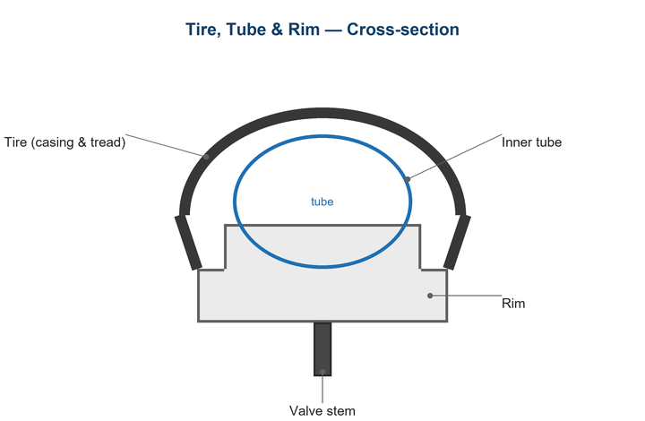
Figure 1. Air can escape at the valve, the bead, or through the casing.

Likely Causes
- A tiny puncture too small to find by sight.
- A loose or failing valve core.
- Dried-out tubeless sealant no longer plugging pores.
- A poor bead seal letting air escape at the rim.
- A damaged valve seal or, on tubes, a perished valve base.
Safety first
- Do not exceed the tire's maximum pressure while hunting for leaks.
- Keep fingers clear when seating a tubeless bead — it can seat with a sharp pop.
- Tubeless sealant can stain; wear gloves and protect surfaces.

Customer Fix — Step by Step
Suitable for home repair with basic tools. Work through the steps in order.
- Inflate the tire and brush soapy water over the whole tire, bead, and valve; watch for growing bubbles.
- If bubbles form at the valve, check the valve core is tight using a valve-core tool.
- For tubed tires, if the leak is in the casing, replace or patch the tube (see TS-005).
- For tubeless, add fresh sealant through the valve, reinflate, and rotate/shake the wheel to spread it across the leak.
- Re-seat a leaking bead by deflating, adding a little soapy water to the bead, and inflating briskly until both beads pop into place.
- Leave the tire inflated and re-check pressure after a few hours to confirm the fix.

Technician Reference
Additional checks and adjustments for service technicians and advanced users.
- Replace a worn or cracked valve core; on tubeless valves, check the rubber grommet and lockring seal.
- Refresh tubeless sealant on a 2–4 month cycle (sooner in hot, dry climates).
- Inspect rim tape for lifting or punctures at spoke holes; re-tape with the correct width if compromised.
- Confirm the tire and rim are tubeless-compatible and the bead diameter matches.
- For a stubborn casing weep, install a tubeless plug or fit a tube as a roadside fix.

Torque & Specifications
Setting | Specification
Tubeless sealant refresh | Every 2 – 4 months
Valve core | Snug by hand + ¼ turn tool
Tubeless seating pressure | Up to sidewall max
Soap test pressure | At or below max only
Tape width | Match internal rim width

Figure 2. Fresh sealant plugs small casing pores that slow-leak air.
Pro tips
- Top up tubeless sealant before it fully dries to avoid clumps.
- A few drops of soapy water at the bead make seating much easier.

When to Visit a Service Center
- A tubeless tire repeatedly fails to seal despite fresh sealant.
- The rim bead seat is damaged or out of round.
- The valve cannot be sealed at the rim.
- You lack a high-volume pump or compressor to seat the bead.
This guide is provided for reference. Torque values are typical starting points — always follow the specific component manufacturer's instructions. © Adventure Works.

